WEEK#

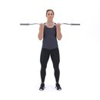
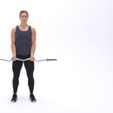
Easy barbell curl:
3 sets of 8 reps.

Date
Set 1
Set 2
Set 3
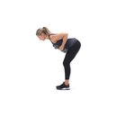
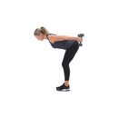
Double arm Tricep Kick back:
3 sets of 8 reps.

Date
Set 1
Set 2
Set 3


Single arm lateral raise:

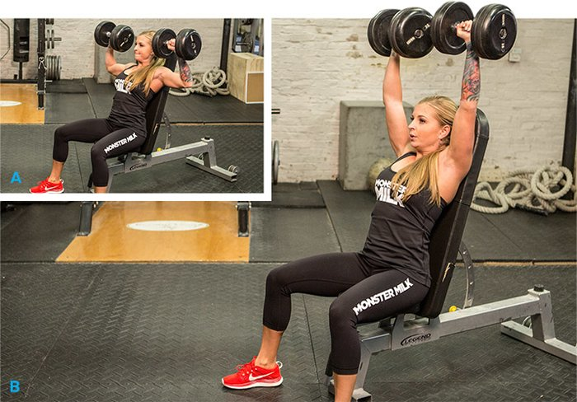
3 sets of 8 reps.

Date
Set 1
Set 2
Set 3

Military dumbbell press:
3 sets of 8 reps.

Date
Set 1
Set 2
Set 3

pg.1

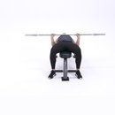
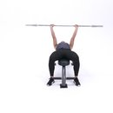
Barbell bench press:

3 sets of 8 reps.

Date
Set 1
Set 2
Set 3

Single arm dumbbell row:
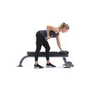
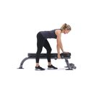
3 sets of 8 reps.

Date
Set 1
Set 2
Set 3

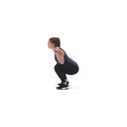

Barbell squat:

3 sets of 8 reps.

Date
Set 1
Set 2
Set 3
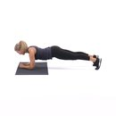
Elbow plank:
3 sets of 8 reps.

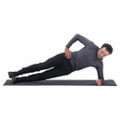
Side plank:
3 sets of 8 reps.

Date
Set 1
Set 2
Set 3

pg.2

